https://github.com/ultralytics/ultralytics

Click on “Open in Colab” In GitHub YOLO 11

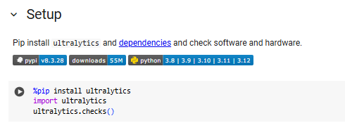
RUN 1.

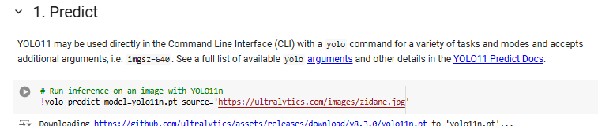
2.

Change the image with video paths and RUN

https://wallpapers.com/images/featured/cristiano-ronaldo-pictures-bc9xghd8s9yni3r6.jpg

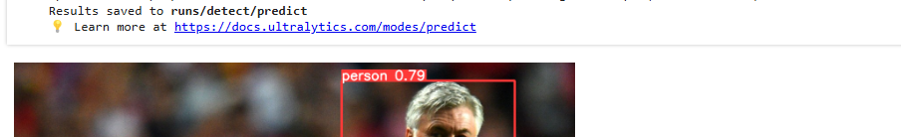
3. For seeing results:

4. You can do following tasks using YOLO
